
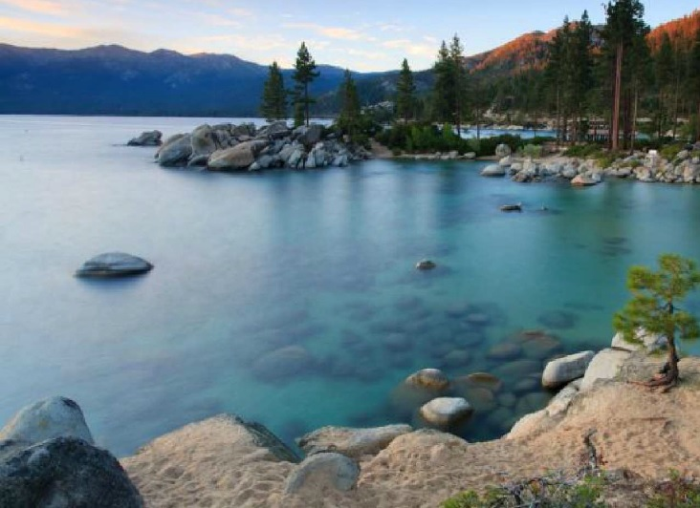
TOURS & TRAVEL
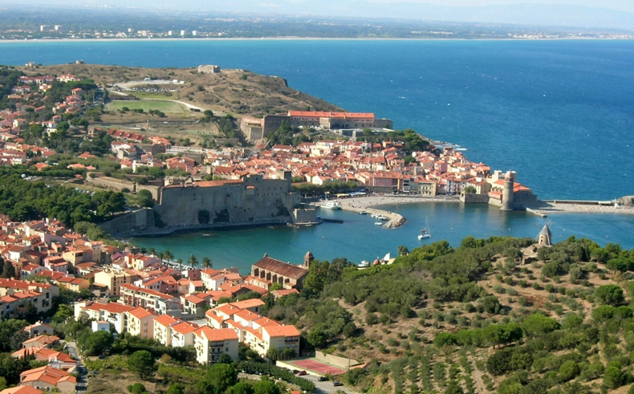
We know that being an alum of Wilson College has many benefits, but did you know that traveling all over the world while taking advantage of big savings and exceptional guides is one of them? The Alumnae Association of Wilson College works with a multitude of travel companies in order to offer you the best deal, on the best travel experience, so that you can get the most out of your journey. Featuring a variety of trips a year to choose from, the AAWC Tours and Travel program is your go-to when planning your next trip. Please view the information below to learn more about how you can become an AAWC traveler!

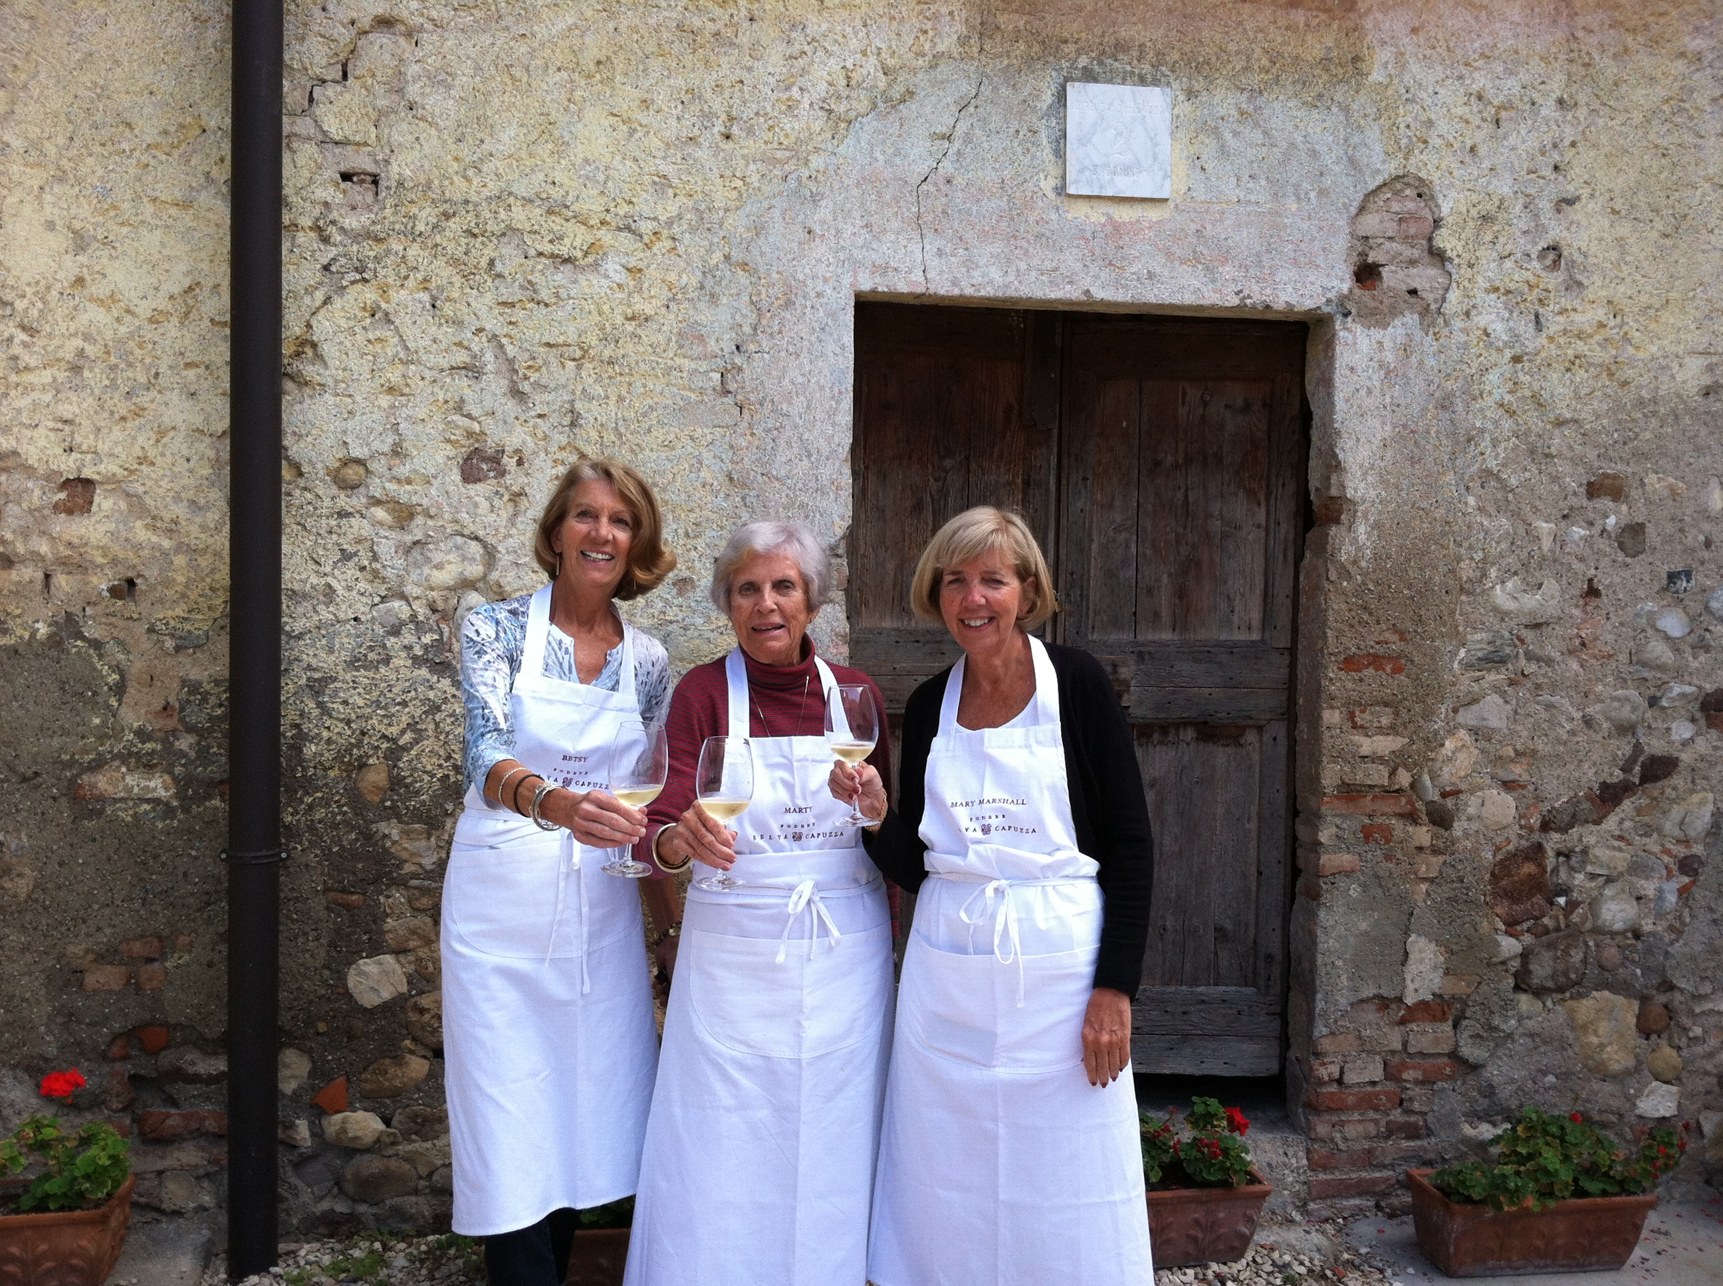
Did you know?
Whenever you purchase a tour directly from the following partners, be sure to mention you are a Wilson graduate. The company will make a donation to the Alumnae Association. This offer includes any trip.
Partner Companies:
AHI Travel: www.ahitravel.com 800-323-7373
GOHAGAN: www.gohagantravel.com 800-922-3088
GO NEXT: www.gonext.com 800-842-9023
Orbridge: www.orbridge.com. 800-639-0079
The Barge Lady: www.bargelady.com. 800-880-0071

Follow our link https://www.wilson.edu/alumnae-tours-and-travel
for more information on Wilson sponsored trips.

Need travel advice? Contact the AAWC Travel desk AAWCTravelDesk@gmail.com.
Seasoned travelers who are members of the AAWC Tours and Travel committee will be happy to assist you.
The Alumnae Association appreciates your support.
Turn over the page for your next adventure ~ Bon voyage!
Remaining 2018 Tours:
OCTOBER 13-21, 2018 “Flavors of Catalonia” The Costa Brava is home to Spain’s most delicious treasures.
Fly to Barcelona – check into a boutique hotel in the village of Emporda with this small-group tour and become immersed in the history and culture that shaped the Iberian seaside villages and their friendly people. $3995 PP/Double (plus air). $5995 Single (very limited; try to find a roommate - plus air). Optional extension 3 nights in Barcelona $1595.
ORBRIDGE (www.wilson.orbridge.com or (866) 639-0079)

EXCLUSIVE ANNOUNCEMENT ~ 2019 Tours:
APRIL 25-29, 2019 Long Weekend Getaway in Iceland with Discover Europe Ltd.
Board Iceland Air from NYC or Boston and arrive in Iceland early Friday morning. From your Reykjavik Hotel you’ll tour the Old Town. Later that evening you’ll embark on your first attempt to view the Northern Lights. Saturday you’ll tour the Icelandic countryside, the Whale Fjord (one of the salmon rivers), relax in a hot spring bath, view a volcanic crater, and enjoy a lobster feast. Sunday choose from a snowmobile to the top of a glacier, ride an Icelandic pony or go in search of whales. Monday – tour the exotic, moonlike Reykjanes peninsula, walk on the North American Ridge enjoy a fisherman’s lunch in Grindavik and then leave for the airport to catch your flight back to the U.S. Pricing to come.
Discover Europe Ltd : www.discovereuropeltd.com 603-563-7077

JUNE 13-21, 2019 “Flavors of Chianti”
Orbridge offers this small-group tour of the hill county in and out of Florence, Italy—with a 7-night stay at a first-class hilltop Tuscan villa with views in the distance of San Gimignano and the towers of Siena. From $4495 per person, double; single availability limited.
Orbridge: www.orbridge.com 800-639-0079
AUGUST 3-14, 2019 “Celtic Kingdoms Cruise” Sailing on Oceania’s Marina
Go Next offers 10 nights starting in London (Southampton), Edinburgh, Invergordon, Glasgow, Dublin, Cork, Portland, and concluding again in London (Southampton). Pricing from $4299 per person, double (airfare included from major gateways). Singles on request only ranging from 150% to 200% of price.
GO NEXT: www.gonext.com 800-842-9023

SEPTEMBER 16-25, 2019 “Symphony on the Blue Danube” featuring Prague
Gohagan & Company has exclusively chartered a deluxe small river ship the MS AMADEUS SILVER II for a custom-designed 10-day journey highlighting the musical heritage of the European Masters. 3 nights in Prague followed by a 5-night river cruise including overnight in Vienna. Features concerts and performances ashore. Disembark in Budapest. Pricing from $3995 per person, double. Early Booking Prices from $3195 per person, double. Limited singles.
GOHAGAN: www.gohagantravel.com 800-922-3088

