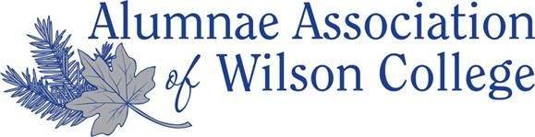
Wilson College Ring it Forward Program
Donor Form

Name: ______________________________ Class Year: ___________ Major/Area of Study: ______________________
Do you have any preferences/restrictions regarding who receives your ring?
(ex. A biology student, a student involved in athletics, a local student, etc.)
______________________________________________________________________________________________________________________________________________________________________________________________________________________________________________________________________________________________________
Any special notes regarding this particular ring? (ex. engraving, condition, etc.)
____________________________________________________________________________________________________________________________________________________________________________________________________
Ring-It- Forward Program Statement of Understanding:
*Donations of rings are not tax-deductible or considered a gift in-kind as neither Wilson College nor the Alumnae Association maintain long term possession of the rings.
* Recipients will be matched via a small committee.
* An alumna with a specific recipient in mind may give directly without the involvement of this committee; however, please notify the Alumni Relations Office of this exchange for record keeping purposes.

Donor Signature: __________________________________________ Date: ______________________

Would you like to be present at the ceremony during which your ring will be presented to the student?
(Circle One) Yes or No

If you have a narrative or statement regarding your ring or your Wilson experience that you would like to share with the student recipient, please feel free to use the back of this form or attach a separate sheet.

(Office Use Only):
Received by Staff: _____________________________________________ Date: ________________
Matched with: _______________________________________________ Date: ________________

Form updated January 2019

