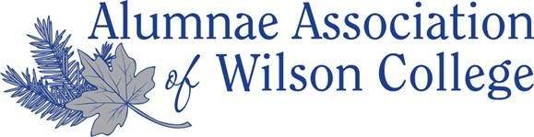
Wilson College Ring it Forward Program
Student/Alumnae/i Request Form

Name: ________________________________ Class Year: ___________ Major/Area of Study: ____________________

What activities are you/were you involved in at Wilson College? (athletics, community service, clubs, etc.)
________________________________________________________________________________________________________________________________________________________________________________________________________________________________________________________________________________________________________________________________________________________________________________________________________
Would you like to share any special notes or information about yourself?
(future goals, interests, hobbies, what Wilson means to you, your Wilson experience etc.)
____________________________________________________________________________________________________________________________________________________________________________________________________________________________________________________________________________________________________________________________________________________________________________________________________________________________________________________________________________________________________________________________________________________________________________________________________________
Ring-It-Forward Program Statement of Understanding:
* Recipients will be matched via a small committee.
* An alumna with a specific recipient in mind may give directly without the involvement of this committee; however, please notify the Alumni Relations Office of this exchange for record keeping purposes.
*Recipients will be encouraged to acknowledge the gift and maintain a relationship with donor when appropriate

Recipient Signature: __________________________________________ Date: ______________________

(Office Use Only):
Matched with: _____________________________________________ Date: ________________

Form updated January 2019

