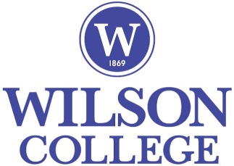
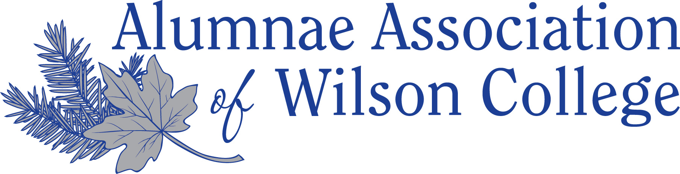

Alumni and Student Activities
Wilson College alumni are committed and engaged in opportunities to support all current Wilson students. The degree of involvement and what is gained from the interactions are up to you.

Learn more…

Aunt Sarah/Uncle Wilson Program
Wilson College Alumni have the unique opportunity to adopt a new relative by participating in the Aunt/Uncle Program, named in honor of our namesake Sarah Wilson. Alums volunteer as “Aunt Sarah or Uncle Wilson” and students sign up to be “nieces or nephews”. The Aunt/Uncle will be in contact with their niece/nephew through a letter/email or an occasional package to brighten the student’s day and to provide encouragement. Local Aunts/Uncles may choose to get together for coffee or a meal. The program builds bonds between former and current students. Some of the pairings last a semester, some through commencement and others, a lifetime.

Food for Finals
The end of semester can be stressful as students are very busy preparing for final exams. Alums have all “been there, done that” – they understand. Each semester there is a “food for finals” week where late night snacks are provided by various campus groups. The Alumnae Association and Alumni Relations Office are proud to be a sponsor of this program and provide encouragement for our students. Volunteers are always welcome.

Career Networking
With over 8,000 living Wilson graduates, one or more are certain to be in career fields of interest to you. Many alumni are willing to provide words of advice, job shadowing, internship opportunities and employment assistance. These connections can be a great asset towards building future career paths. It is never too early or too late to develop your network. Reach out to connect and work with us through combined efforts with the Wilson Career Development Center. Opportunities for networking are offered every semester or by request.

Internship Gift Program
The Alumnae Association sponsors an Internship Gift Program to supplement funds needed for a student to complete a desired internship experience. The gift is intended for unusual expenses that might prohibit the completion of the experience, not to be used toward tuition or routine expenses. Individuals make restricted gifts to this fund. Applications are available online or at the Alumni House.

(turn page over)
Silver Lining Fund
Individuals provide restricted funds to the Alumnae Association to be available in the case of a student experiencing an immediate crisis situation that directly affects the safety or the ability of the student to continue educational progress at Wilson. The Dean of Students assists students making connections with resources and support for assistance.
Ring it Forward
The Alumnae Association invites alums to donate their Wilson class ring so it may be passed to the new Wilson generation. This is another great opportunity to pair an alumna/us and a current student to keep the spirit of Wilson Traditions alive.

Donor Recognition Dinner
Hosted by Institutional Advancement, student scholars are invited to assist in giving thanks to generous donors who support Wilson College students philanthropically. Many student recipients write letters of thanks coordinated through the office.

Alumni Collaboration with Admissions
Alumni volunteers write note cards to accepted students and serve as greeters on accepted student day. On occasion young alums serve as speakers on panel discussions to share their Wilson experience to prospective students and families.

Senior Activities
Alumni volunteers interact and provide treats at annual events such as grad fair and senior bash.

Blue and Silver Line
Alumni representatives from all decades lead in the seniors at Commencement to honor and celebrate the graduating class joining the ranks of the Alumnae Association of Wilson College. Each year alums tell us that this is a very rewarding and heartwarming experience. Please join us!

Student Workers
The Alumni Relations Office has work study positions available through the Financial Aid office. Students are also hired to assist in the annual Reunion Weekend. Students assist in programming logistics, greeting and directions, golf cart transportation and have a great time getting to know alums of all ages.

Emporium
The Alumnae Association and Alumni Relations Office coordinate the sale of unique Wilson items, ranging from t-shirts, notecards, posters and much more. Items may be purchased online or at our many events.

Contact us:
Alumni Relations at ARoffice@wilson.edu or 717-262-2010
Alumnae Association of Wilson College at aawc@wilson.edu

(updated Spring 2021)

